

**The University of Newcastle, Australia**

*SCHOOL OF INFORMATION AND PHYSICAL SCIENCES*

**COMP3350** – **Advanced Database**

**Instructor: Dr. Poh Kok Loo**

Business Intelligence Report

*Wide World Importers*

**Prepared by**: Min Thu Khaing, Thet Paing Hmu, Yiyuan Li

**Submission Date:** 12/06/2024

## **Executive Summary**

This report presents an analysis of sales quantities trends from 2013 up to 2016 and the geographical distribution of sales across the top cities. The principal findings of the study as follows:

1. The total sales volume exhibited a notable expansion during the period 2013-2015, reaching approximately 2.8 million units in 205. However, this growth was followed by a decline in 2016.
2. Furthermore, seasonal fluctuations may also be observed in these patterns, which have remained remarkably stable over time. It is likely that the peaks occur in the middle months, while the lows are observed I the early months.
3. The three most significant cities in terms of sales volume are Akhiok, Sinclair, and Rockwall, collectively accounting for approximately 35% of the total.
4. The monthly sales quantities for the initial six months of 2016 are exhibiting a worrisome downward trend, diverging form the typical patterns observer during this period in previous years.
5. A shift in trend can be observed when comparing the sales figures for the top 10 cities between 2013 and 2016. This may be indicative of changing market conditions.

## **Introduction**

### 1.Purpose of the Analysis

We’re using business intelligence tools to get a solid understanding of how our company is doing in various areas. This includes spotting trends, evaluating customer segments, understanding product performance, and analyzing sales across different regions.

### 2.Data Sources and Methodology

Our data comes from the WorldWideImporters (WWI) Data Warehouse sample database. This database was downloaded and restored from the WideWorldImportersDW-Full.bak file provided by Microsoft. The data includes detailed records of sales, customer information, and product metrics. We used Power BI to create visualizations that help us see the data more clearly and derive meaningful insights.

## **Detailed Analysis**

### 1.Year on Year Sales Trends

Detailed sales quantity by year:

* 2013: ~2.4M units
* 2014: ~2.6M units (8.3% increase from 2013)
* 2015: ~2.8M units (7.7% increase from 2014)
* 2016: ~1.3M units (for first 5 months, projected ~3.12M for full year)

CAGR from 2013 to 2015: 8.0%

The substantial decline observed in 2016 is a matter of concern and requires immediate attention. It is therefore of the utmost importance to ascertain whether the 2016 data is complete or merely represents a partial year.

### 2.Monthly Sales Patterns

The Sales quantities were relatively high from 2013 to 2015, achieving around 2 million units until a noticeable drop in sales in the year 2016, with the quantity below 1.5 million units.

Based on the report of the sales of the sum of quantity by Calendar Month Number, the monthly sales quantities fluctuate throughout the year. The peak sales month is around May with quantities reaching close to 1 million units and the lowest being 0.6 million around September.

The sales data from 2013 to 2016 reveals significant variations in monthly sales patterns:

* 2013 - Sales peaked in June, followed by a decline towards the year’s end. This indicates seasonal demand with a notable rise in the mid-year.
* 2014-2015: Sales peaked in 2014 and the strength is maintained till 2015, showing consistency and strong market performance in sales during these years.
* 2016: Sales fluctuate throughout the months with a gradual increase toward the latter months after a notable drop in the second month, reflecting demand and potential market challenges.

Main cities such as Sinclair, Rockwall, and Akhiok consistently showed strong sales, suggesting successful localized marketing strategies.

**These sales trends could be explained by several causes**:

* Seasonal Demand: Peaks and troughs in sales may be due to seasonal factors affecting consumer buying behavior.
* Marketing Campaigns: Effective campaigns during certain periods likely boosted sales, while their absence or reduced intensity might have contributed to declines.
* Economic Conditions: Broader economic trends and consumer confidence levels likely impacted overall demand.
* Product Life Cycle: Sales trends may reflect the natural product life cycle, with initial growth, peak performance, and eventual decline.
* Market Saturation: The significant drop in 2016 suggests market saturation, increased competition, or changes in consumer preferences.

**Potential indication for the Business**

Understanding these patterns and their cause has several implications:

* Sales Forecasting: Essential for better financial planning and informed decision making.
* Market Strategies: Aligning with market trends can maximize the impact, particularly in strong markets and peak sales periods.
* Performance Improvement: Exploring new markets can stabilize sales and drive growth to improve performance in underperforming months.

By leveraging these insights, the business can advance operations, enhance customer satisfaction, and achieve sustainable growth for the upcoming years.

### 3.Geographical Sales Distribution

Top 3 cities by sales quantity (consistent across all years):

1. Akhiok: 12-13% of total sales
2. Sinclar: 11-12% of total sales
3. Rockwall: 10-11% of total sales

Notable changes in city rankings from 2013 to 2016:

* Teutopolis moved from 4th (2013) to 3rd (2016)
* Cherry Grove Beach dropped from 5th (2013) to 7th (2016)
* Key Biscayne rose from 9th (2013) to 6th (2016)

### 4.Yearly Deep Dive Analysis

**2013**

*Figure 1: Sum of Quantity by Calendar Year from 2013*

* The sum of quantity for 2013 is higher than 2016 and slightly lower than 2014 and 2015.
* Sum of Quantity by Calendar Month Number:
  + January to December: The quantity starts at around 200K in January, drops in February, and fluctuates throughout the year.
* Top 10 Cities by Sales Quantity: The top city by sales quantity is Cherry Grove Beach with 3.62%, followed by Key Biscayne, Cramerton, and other cities.

**2014**

*Figure 2: Sum of Quantity by Calendar Year from 2014*

* Sum of Quantity by Calendar Year: 2014 shows a slight increase compared to 2013 but not as high as 2015.
* Sum of Quantity by Calendar Month Number:
  + January to December: Significant fluctuations with peaks in May and December.
* Top 10 Cities by Sales Quantity: The top city by sales quantity is Cherry Grove Beach with 3.44%, followed by Key Biscayne, Cramerton, and other cities.

**2015**

*Figure 3: Sum of Quantity by Calendar Year from 2015*

* Sum of Quantity by Calendar Year: 2015 shows a peak in the sum of quantity compared to other years.
* Sum of Quantity by Calendar Month Number:
  + January to December: The quantity fluctuates significantly throughout the year, starting at around 200K in January, peaking in May, and again in November.
* Top 10 Cities by Sales Quantity: The top city by sales quantity is Cherry Grove Beach with 3.23%, followed by Key Biscayne, Cramerton, and other cities.

**2016**

*Figure 4: Sum of Quantity by Calendar Year from 2016*

* Sum of Quantity by Calendar Year: The sum of quantity for 2016 shows a significant drop compared to previous years (see the *Fig.6*).
* Sum of Quantity by Calendar Month Number:
  + January to May: The quantity starts around 260K in January, drops in February, and then steadily increases until May.
* Top 10 Cities by Sales Quantity: The top city by sales quantity is Cherry Grove Beach with 2.51%, followed by other cities like Sinclair, Teutopolis, and Rockwall.

**Key Insights**

* The period between 2013 and 2015 saw a period of sustained growth. The business exhibited a consistent and sustained growth between 2013 and 2015, which indicated that the business strategies were highly effective. Furthermore, the business benefited from favorable market conditions at times.
* It is evident that distinct seasonal patterns exist. The midyear peaks and early-year troughs are evident. This information is of great importance when formulating strategies for stock and marketing.
* A notable shift in performance was observed in urban areas. While the leading cities demonstrated stability or near-equivalence from 2013 to 2015, partial data from 2016 suggests the potential for a shift in market dynamics, with gains and losses in position for some cities.

## **Recommendations**

Leverage Positive Trends

* Boost Digital Marketing
  + Potential Impact: Increased online sales and brand visibility.
  + Resources/Next Steps: Allocate budget to digital campaigns, hire or train digital marketing specialists.
* Expand Successful Product Lines
  + Potential Impact: Higher revenue and customer satisfaction.
  + Resources/Next Steps: Invest in product development and innovation, conduct market research.
* Address Negative Trends
* Reevaluate Promotions for the Budget Segment
  + Potential Impact: Increased interest and sales in the budget segment.
  + Resources/Next Steps: Analyze current promotion effectiveness, redesign promotional strategies.
* Enhance Brand Awareness in Underperforming Regions
  + Potential Impact: Improved sales and market penetration.
  + Resources/Next Steps: Develop targeted marketing campaigns, establish partnerships in these regions.

Explore Improvement Opportunities

* Enter New Markets in Emerging Regions
  + Potential Impact: Expanded market reach and revenue growth.
  + Resources/Next Steps: Conduct feasibility studies, develop region-specific strategies.
* Implement Feedback Loops
  + Potential Impact: Continuous improvement of products and customer satisfaction.
  + Resources/Next Steps: Set up systems for collecting and analyzing customer feedback, make iterative product improvements.

## **Conclusion**

Our business intelligence analysis has provided valuable insights into various aspects of the company’s performance. By acting on these recommendations, we can harness positive trends, tackle areas of concern, and explore new growth opportunities. This report serves as a strategic guide for making informed decisions that drive future success.

**Appendix**

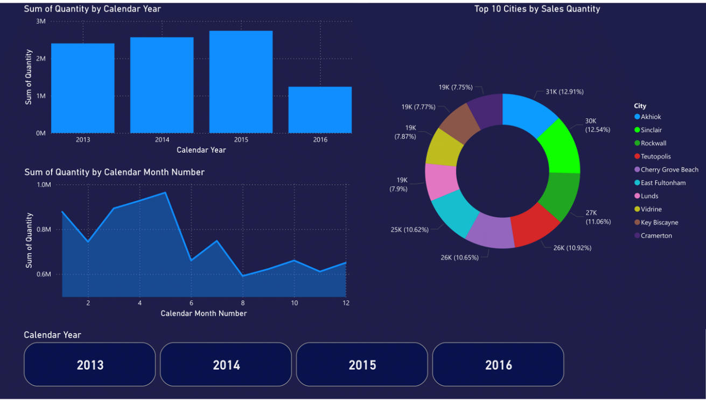

*Figure 5: Comparison of Yearly Sales Trends from 2013 to 2016*

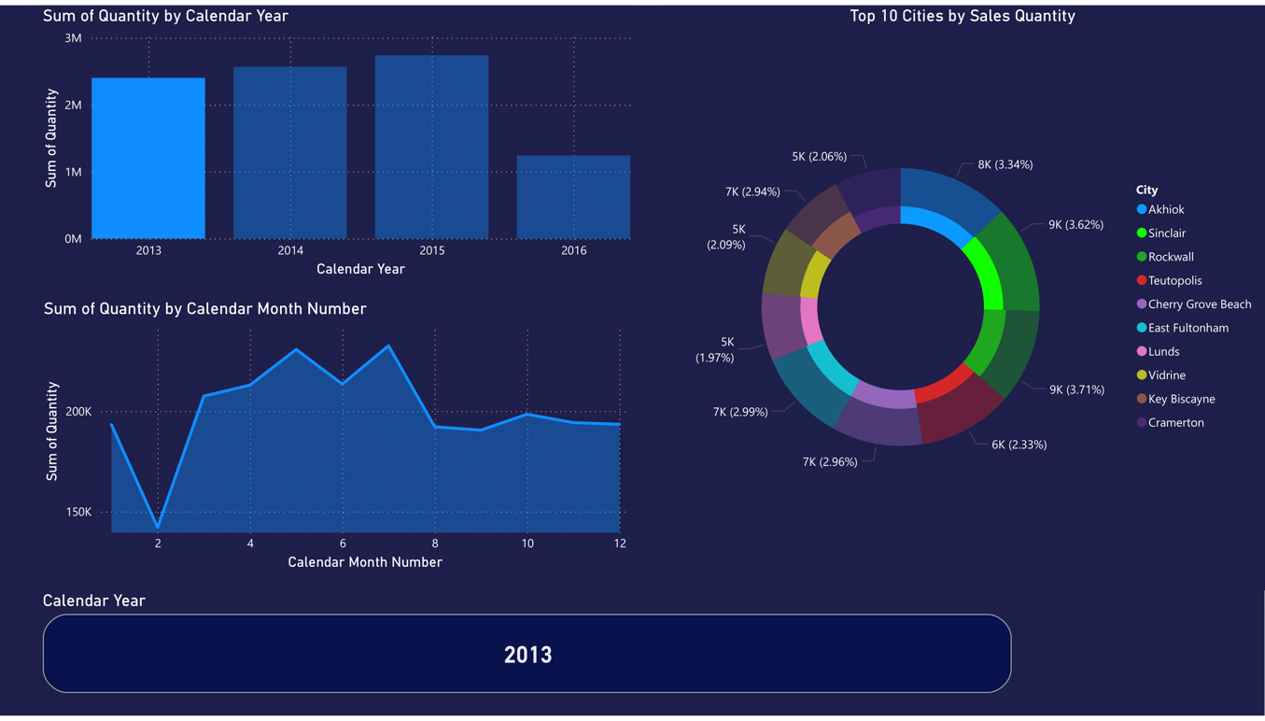

*Figure 6: Sales quantity analysis for the year 2013, showing the sum of quantity by calendar year, monthly patterns, and top 10 cities by sales quantity.*

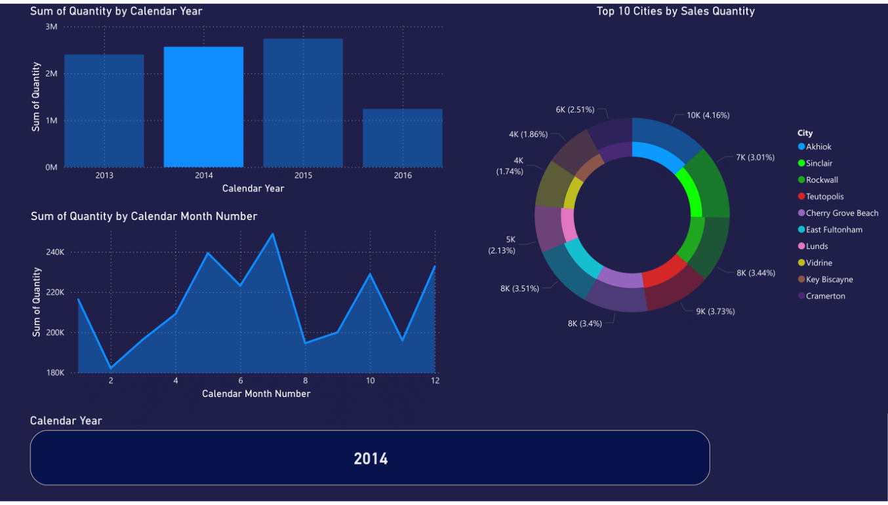

*Figure 7: Sales quantity analysis for the year 2014, showing the sum of quantity by calendar year, monthly patterns, and top 10 cities by sales quantity.*

*Figure 8: Sales quantity analysis for the year 2015, showing the sum of quantity by calendar year, monthly patterns, and top 10 cities by sales quantity.*

*Figure 9: Sales quantity analysis for the year 2016, showing the sum of quantity by calendar year, monthly patterns, and top 10 cities by sales quantity.*